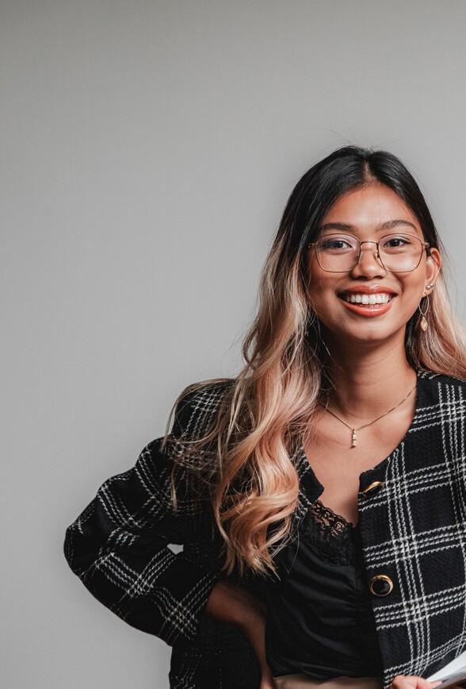OLIVIA WILS
FASHION STYLIST
I'm a fashion stylist who has been in the industry for over 4 years. My personal style can be described as vintage, sophisticated, and romantic.

Experience

Skills
- Good communication skills
- Good interpersonal skills
- Good writing skills
- Good organizational skills
- Expert knowledge on the latest fashion trends

Education
I attended the MA in Fashion Styling & Visual Merchandising at the “Dorato Fashion School of California.

Get in touch
Phone : + 123 456 7890
E-mail: contact@jobfirstadvisors.com

Address : 123 Anywhere St. Any City
JUNIOR FASHION STYLIST
Mega Sense Fashion Blog | 2012 - 2014
Helped the lead stylists with dressing the models for shoots Organized the magazine's closet and made sure that all clothes and accessories were updated

FASHION STYLIST ASSISTANT
Magazine | 2013 - 2018
Helped the lead stylists with dressing the models for shoots Organized the magazine's closet and made sure that all clothes and accessories were updated

SENIOR FASHION STYLIST
Neon Lush Magazine | 2014 - present
Styles models for shoots
Develops a budget for clothing and accessories for each shoot
Provides crucial insights to new trends for the season

ASSISTANT
Fashion | 2013 - 2018
Styles models for shoots
Develops a budget for clothing and accessories for each shoot

COVER LETTER

Lorem ipsum dolor sit amet, consectetur adipiscing elit. Sed viverra ante eu vulputate tempus. Vivamus in nunc elit. Suspendisse a pellentesque sapien. Donec massa erat, dignissim ac sagittis ac, condimentum nec purus. Morbi commodo sit amet odio vitae viverra. Aenean egestas feugiat lobortis. Aenean a faucibus magna. Maecenas quis urna in magna maximus accumsan ut nec libero. Morbi congue dui vel quam blandit dictum. Sed augue odio, semper a lectus et, lacinia pulvinar erat. Donec eget magna erat.

Cras magna tellus, cursus non feugiat eget, pulvinar sed risus. Nullam vestibulum sollicitudin tincidunt. Nulla purus augue, semper a vehicula a, vulputate et ipsum. Pellentesque habitant morbi tristique senectus et netus et malesuada fames ac turpis egestas. Etiam sit amet turpis nec risus dictum lobortis. Nunc ac nibh quis augue elementum tincidunt. Sed dapibus congue fermentum. Donec eu egestas elit, quis lobortis massa. Etiam malesuada aliquet fermentum. Duis hendrerit fringilla dui, vel volutpat dolor faucibus sed.
Olivia Wils

